AMAZON SALES & BUSINESS PERFORMANCE ANALYSIS
Data Analyst Case Study
Analysis Period: January 2023 to December 2025
Dataset: amazon_sales_dataset
Tools Used: PostgreSQL, Microsoft Excel, Power BI
Prepared by: Dhanush Narla
Contents
Executive Summary 1
1. Business Requirements 2
2. Business Questions 4
3. Data Quality, Cleaning and Validation 5
4. SQL Business Analysis 7
5. Excel MIS and Validation 12
6. Power BI Dashboard 14
7. Consolidated Business Insights 18
8. Patterns and Trends 19
9. Recommendations 20
10. Conclusion 21

Executive Summary
This project analyzes Amazon sales and business performance using a synthetic dataset. The analysis combines SQL for data cleaning, validation and detailed analysis; Excel for MIS reporting and reconciliation; and Power BI for an interactive business dashboard.
The completed project follows one consistent workflow:
Raw Dataset
↓
SQL Data Profiling, Cleaning & Validation
↓
Cleaned Dataset (Database)
↓
SQL Business Analysis
↓
Excel MIS Reconciliation
↓
Power BI Interactive Dashboard
↓
Insights & Recommendations
Supporting Deliverables
File | Purpose
amazon_sales_dataset.csv | Raw Amazon sales synthetic dataset used as the source
Data Quality_Cleaning_Validation.sql | Data profiling, cleaning and validation queries
Business Analysis.sql | SQL business-analysis queries
Amazon Sales Analysis.xlsx | Excel MIS and KPI validation
Power BI Interactions.mp4 | Interactive Power BI dashboard walkthrough
Amazon Sales Case Study.pptx | Project presentation and business analysis summary

1. Business Requirements
1.1 Business Problem
Management requires a consolidated view of sales, profitability, customer behaviour, product performance, geographic performance, delivery outcomes and returns. The purpose is to identify the factors that drive revenue and profit, highlight operational issues, and support data-driven business decisions.
1.2 Project Objectives
The objectives of this project are to:
- Clean and validate the available amazon_sales_dataset.
- Measure overall sales, profit and profitability performance.
- Analyze monthly sales and profit-margin trends.
- Identify the strongest-performing categories, products, and cities.
- Compare customer segments.
- Evaluate delivery status, shipping-mode performance, returns and cancellation patterns.
- Build an Excel MIS for management reporting.
- Build an interactive Power BI dashboard for exploration and decision-making.
- Provide actionable business recommendations based on validated findings.
1.3 Scope
The project uses all available validated records in the cleaned dataset.
- Analysis period: January 2023 to December 2025.
- Total cleaned records: 25,000 unique orders.
- Financial analysis: Delivered orders only.
- Operational analysis: All orders, including Delivered, Returned and Cancelled orders.
- Geographic analysis: City and state level.
- Customer analysis: Customer Type, Customer Value, and Purchase Frequency.
1.4 KPI Definitions
KPI | Definition
Total Orders | Distinct count of order_id across all orders
Total Units | Sum of quantity for total units
Delivered Orders | Distinct count of orders with delivery_status = Delivered
Delivered Units | Sum of quantity for Delivered orders
Total Sales | Sum of sales for Delivered orders
Total Profit | Sum of profit for Delivered orders
Total Discount | Sum of discount for Delivered orders
Profit Margin % | Total Profit ÷ Total Sales × 100
Returned Orders | Distinct count of Returned orders
Returned Units | Sum of quantity for Returned orders
Return Rate % | Returned Orders ÷ Total Orders × 100
Cancelled Orders | Distinct count of orders with delivery status = Cancelled
Cancelled Units | Sum of quantity for Cancelled orders
Cancellation Rate % | Cancelled Orders ÷ Total Orders × 100
Average Order Value | Total Sales ÷ Delivered Orders
Total Customers | Distinct count of customer_id across all customers
Never Contributed Customers | Distinct count of customer_id across all customers who are never contributed in sales in the end

2. Business Questions
Overall Performance
BQ1. What is the overall business performance in terms of orders, units sold, sales, profit, profitability, returns and cancellations?
Sales and Profitability
BQ2. How do monthly sales, profit and profit margin change over time?
BQ3. Which product categories generate the highest sales and profit, and how does profitability differ across categories?
BQ4. Which products contribute the most sales and profit, and which products show comparatively weaker profitability?
BQ5. How do discount bands relate to sales, profit and profit margin?
Customers
BQ6. How do New and Returning customers differ in orders, sales, profit and profitability?
BQ7. Which Customer Type, Customer Value, and Purchase Frequency contribute the most orders, sales, profit and average order value?
Geography
BQ8. Which cities generate the highest sales, profit and order volume?
Delivery, Shipping and Returns
BQ9. How are orders distributed across Delivered, Returned and Cancelled statuses?
BQ10. How do shipping modes differ in orders, units, sales, profit, profit margin and returned orders?
BQ11. Which cities have higher average delivery times and how does delivery performance vary by city?
BQ12. What is the overall return rate, and how does return rate vary across categories?
BQ13. What are the main reasons for returns?
Supporting Operational Question
BQ14. How is sales distributed across payment methods?

3. Data Quality, Cleaning and Validation
3.1 Data Quality Approach
Data quality work was completed before business analysis. The purpose was not only to remove incorrect records but also to investigate whether blank, zero or negative values were valid business outcomes.
The data-quality process included:
- Data profiling
- Duplicate investigation
- Missing-value investigation
- Data standardization
- Formula validation
- Business-rule validation
- Final record-count and date-range validation
3.2 Data Quality Summary
Area | Issue Identified | Final Treatment
Duplicate records | 250 exact duplicate records found | Removed
Raw dataset size | 25,250 records | Reduced to 25,000 unique orders
Return reason | 89 returned orders had missing return reasons | Retained as NULL because the true reason was unknown (87 after removing duplicate rows)
Return reason for non-returned orders | Not applicable for Delivered and Cancelled orders | Standardized as N/A where appropriate
Delivery date | Missing for Cancelled orders | Retained as NULL because delivery did not occur
Delivery days | Not applicable for Cancelled orders | Retained as NULL
Customer rating | Not applicable for Cancelled orders | Standardized as N/A where appropriate
Category values | Inconsistent capitalization/naming | Standardized
Payment method values | Inconsistent capitalization/naming | Standardized
Negative profit | 1,129 negative-profit records | Retained after validation because losses are valid business outcomes
Zero financial values | 5,615 records with zero values | Retained after investigation because they were valid for returned/cancelled transactions
Geography | City/state mismatches identified | Investigated and corrected
Calculated fields | Formula consistency checked | Validated
Status relationships | Delivery, return and cancellation logic checked | Validated

3.3 Important Cleaning Decisions
Duplicate Records
The raw dataset contained 25,250 records, while only 25,000 unique orders were expected after duplicate checking. A total of 250 exact duplicate records were identified and removed. This ensured that sales, profit, units and order counts were not overstated.
Missing Return Reasons
Returned orders had no recorded return reason. These values were retained as NULL because the reason could not be reliably inferred. Assigning an assumed reason would have introduced inaccurate data into the analysis.
Cancelled Orders
Cancelled orders do not have a delivery date or delivery duration because delivery did not occur. These values were retained as NULL rather than replaced with zero, because zero would incorrectly imply same-day delivery.
Negative Profit
Negative-profit records were validated and retained. A negative profit represents a business loss and is analytically important. Removing these records would create an unrealistically positive profitability picture.
Standardization
Category and payment-method values were standardized to ensure that the same business value was not split across multiple labels because of inconsistent capitalization or naming.
3.4 Final Validation
The cleaned dataset was validated before use in Excel and Power BI.
Validation Item | Final Result
Cleaned record count | 25,000
Earliest order date | 01 January 2023
Latest order date | 31 December 2025
Analysis period | 36 months
Duplicate records | Removed
Financial formula checks | Passed
Delivery-status logic | Validated
Cleaned dataset readiness | Approved for analysis

4. SQL Business Analysis
4.1 Overall Business Performance
This analysis measures orders, units, sales, profit, %, customers, returns and cancellations.
Metric | Result
Total Orders | 25,000
Total Units | 53,366
Delivered Orders | 19,450
Delivered Units | 41,825
Gross Sales | ₹337.65M
Total Sales | ₹309.96M
Total Discount | ₹27.69M
Total Profit | ₹105.02M
Profit Margin % | 33.88%
Returned Orders | 2,994
Returned Units | 6,148
Return Rate % | 11.98%
Cancelled Orders | 2,556
Cancelled Units | 5,393
Cancellation Rate % | 10.22%
Total Customers | 8,448
Contributed Customers | 7,960
Never Contributed Customers | 488

Finding: The dataset contains 25,000 orders, including 19,450 delivered orders. Delivered orders generated ₹309.96M in sales and ₹105.02M in profit, resulting in a 33.88% profit margin. Returned and cancelled orders represent a significant share of total orders.

4.2 Monthly Sales and Profitability Trend
This analysis compares monthly delivered-order sales, profit and profit margin from January 2023 to December 2025.
Month | Delivered Orders | Delivered Units | Total Sales | Total Profit | Profit Margin %
Jan 2023 | 573 | 1,232 | ₹8.80M | ₹2.81M | 31.86%
Feb 2023 | 493 | 1,087 | ₹7.93M | ₹2.73M | 34.48%
Mar 2023 | 532 | 1,150 | ₹7.10M | ₹2.38M | 33.60%
Apr 2023 | 542 | 1,186 | ₹10.32M | ₹3.45M | 33.46%
... | ... | ... | ... | ... | ...
... | ... | ... | ... | ... | ...
Nov 2025 | 492 | 1104 | ₹7.64M | ₹2.57M | 33.64%
Dec 2025 | 528 | 1141 | ₹8.11M | ₹2.75M | 33.94%

Finding: Monthly sales fluctuated considerably. Sales reached a high of ₹10.32M in April 2023 and a low of ₹6.08M in June 2025. Profit margins ranged from 30.84% to 36.55%, with most monthly values close to the 33%–35% range.

4.3 Category Performance
This analysis compares delivered sales and profit across product categories.
Category | Sales | Profit
Electronics | ₹121.25M | ₹41.99M
Furniture | ₹102.62M | ₹35.00M
Home & Kitchen | ₹28.87M | ₹9.90M
Sports & Fitness | ₹18.45M | ₹6.18M
Footwear | ₹11.96M | ₹3.93M

Finding: Electronics generated the highest sales and profit, followed by Furniture. Together, these categories generated ₹223.87M.

4.4 Product Performance
This analysis compares delivered sales and profit across products.
Finding: A relatively small group of products, including Office Chair, Study Table, Sofa Set, Wardrobe, Wooden Bookshelf, Bed Frame, Smartphone, Laptop, Bluetooth Speaker and Router, contributes substantial sales.

4.5 Discount Analysis
This analysis compares delivered sales, profit and profit margin across discount bands.
Discount Band | Delivered Orders | Total Discount | Total Sales | Total Profit | Profit Margin %
No Discount | 7,864 | ₹0.00M | ₹133.41M | ₹52.45M | 39.32%
Low Discount | 3,039 | ₹0.30M | ₹3.84M | ₹0.96M | 24.86%
Medium Discount | 2,927 | ₹1.06M | ₹10.06M | ₹3.00M | 29.86%
High Discount | 2,823 | ₹3.11M | ₹25.17M | ₹7.78M | 30.92%
Very High Discount | 2,797 | ₹23.22M | ₹137.48M | ₹40.83M | 29.70%

Finding: The No Discount band recorded the highest profit margin at 39.32%. The Very High Discount band generated the highest sales but had a lower margin of 29.70%. The Low Discount band recorded the lowest margin at 24.86%.

4.6 New versus Returning Customers
The analysis compares New and Returning customers by delivered orders, delivered units, sales, profit and profit margin %.
Customer Type | Delivered Orders | Delivered Units | Sales | Profit | Profit Margin %
New | 10,615 | 22,812 | ₹169.89M | ₹57.79M | 34.02%
Returning | 8,835 | 19,013 | ₹140.07M | ₹47.23M | 33.72%

Finding: New customers contribute more delivered orders, units, sales and profit than Returning customers. Returning customers remain commercially important and show a comparable profit margin.

4.7 Purchase Frequency Analysis
This analysis compares One-Time, Occasional, Frequent and Highly Frequent customers by delivered orders, sales, profit and profit margin.
Purchase Frequency | Delivered Orders | Sales | Profit
Occasional | 12,296 | ₹199.79M | ₹67.59M
Frequent | 5,417 | ₹84.74M | ₹28.70M
One-Time | 1,214 | ₹18.53M | ₹6.46M
Highly Frequent | 523 | ₹6.90M | ₹2.27M

Finding: Occasional customers contribute the highest sales and profit. Frequent customers contribute less overall value but represent the strongest repeat-purchase group.

4.8 Customer Value Analysis
This analysis compares Budget, Regular and Premium customers by delivered orders, sales, profit, profit margin and average order value.
Customer Value | Delivered Orders | Sales | Profit | Profit Margin % | Avg Order value
Budget | 6,458 | ₹103.46M | ₹35.66M | 34.47% | ₹16,020.25
Regular | 6,492 | ₹104.73M | ₹35.16M | 33.57% | ₹16112.76
Premium | 6,500 | ₹101.77M | ₹34.20M | 33.60% | ₹15676.30

Finding: Regular customers contribute the highest sales and Budget customers contribute the highest profit, while Premium customers contribute the lowest commercial value.

4.9 Customer Ratings
This analysis summarises the distribution of recorded customer ratings.
Rating | Count
5 | 5650
4 | 3811
3 | 2353
2 | 1603
1 | 1261

Finding: Ratings of 4 and 5 account for most recorded ratings, indicating generally positive customer feedback. Lower ratings are present but represent a smaller share.

4.10 Geographic Performance
This analysis compares customer distribution and sales performance across states and cities.
Finding: Customers and sales are distributed across several states and cities. Maharashtra has the largest customer base, while multiple cities contribute materially to sales.

4.11 Delivery Status and Shipping Mode
This analysis compares order outcomes and sales performance across delivery statuses and shipping modes.
Status | Share
Delivered | 77.80%
Returned | 11.98%
Cancelled | 10.22%

Standard shipping generates the largest sales value.
Shipping Mode | Sales
Standard | ₹184.19M
Express | ₹93.91M
Same-Day | ₹31.87M

Finding: Standard shipping is central to current operations, while returned and cancelled orders represent important operational outcomes that affect customer experience and business performance.

4.12 City-Level Delivery Performance
This analysis compares average delivery time across cities.
Finding: Average delivery time ranges from approximately 3.54 days in Pune to 3.80 days in Patna among the cities analysed.

4.13 Return Reasons
This analysis compares returned orders across recorded return reasons.
The recorded return reasons were:
Return Reason | Returned Orders | Share
Defective Product | 342 | 11.76%
Better Price Available | 336 | 11.56%
Size/Fit Issue | 335 | 11.52%
Wrong Item Delivered | 334 | 11.49%
Not as Described | 318 | 10.94%
Late Delivery | 318 | 10.94%
Changed Mind | 316 | 10.87%
Quality Not Satisfactory | 313 | 10.77%
Received Damaged | 295 | 10.15%
Total with Recorded Reason | 2,907 | 100.00%

Finding: No single return reason dominates. Recorded returns are distributed across defective products, pricing, size or fit, incorrect delivery, product descriptions, late delivery, quality and product damage.
Category return-rate finding
The category result also supports this conclusion:
- Highest return rate: Footwear — 12.71%
- Lowest return rate: Sports & Fitness — 11.01%
The relatively narrow range suggests that returns are a broader business issue rather than a problem limited to one category.

5. Excel MIS and Validation
5.1 MIS Assessment
The Excel MIS reporting workbook contains:
- A consolidated KPI block.
- Pivot tables for recurring performance analysis.
- Pivot charts for management review.
- Delivered-order filters for financial consistency.
- Monthly, category, product, customer, geographic and operational reporting.
- Reconciliation with SQL and Power BI results.
5.2 Excel MIS Structure
The Excel MIS includes the following reporting areas:
MIS Area | Purpose
Executive KPI Block | Tracks core orders, units, sales, discount, profit and margin
Monthly Sales Trend | Monitors sales across 36 months
Category Performance | Compares category sales and profit
Product Performance | Identifies top products and buttom products
Discount Band | Reviews sales an profit based on discount
Customer Analysis | Compares customer type, value, and purchase frequency
Geographic Analysis | Reviews city/state performance
Delivery and Returns | Tracks shipping, return outcomes

5.3 Validation Results
The Excel MIS reconciles with SQL and Power BI for core delivered-order financial metrics.
Metric | SQL | Excel MIS | Power BI
Delivered Orders | 19,450 | 19,450 | 19,450
Total Units Sold | 41,825 | 41,825 | 41,825
Total Sales | ₹309.96M | ₹309.96M | ₹309.96M
Total Profit | ₹105.02M | ₹105.02M | ₹105.02M
Profit Margin | 33.88% | 33.88% | 33.88%

Finding: The three tools reconcile for the major KPIs. SQL remains the source for transformation and detailed analysis; Excel provides the management-reporting layer; Power BI provides interactive exploration and visualization.
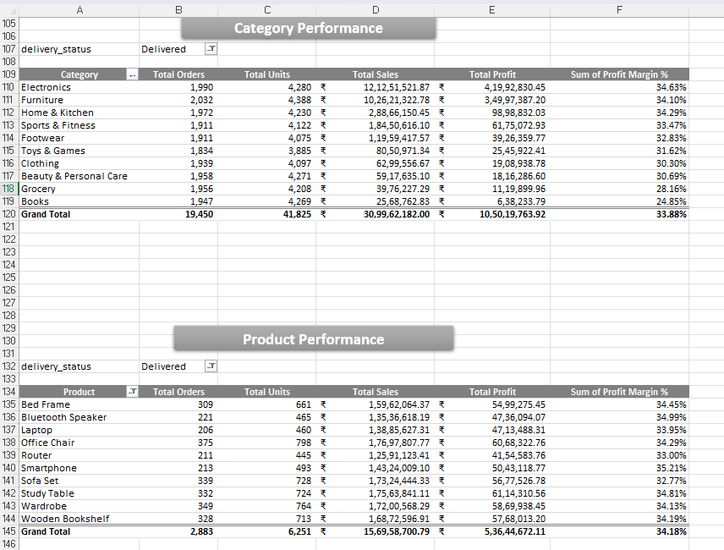

6. Power BI Dashboard
The Power BI dashboard contains five pages:
- Executive Overview
- Category & Product: Sales & Profit
- Customer Insights
- Geography
- Delivery & Returns
6.1 Executive Overview
The Executive Overview presents:
- Total Orders
- Total Units
- Delivered Orders
- Delivered Units
- Total Sales
- Total Profit
- Returned Orders
- Returned Units
- Return Rate %
- Cancelled Orders
- Cancelled Units
- Cancellation Rate %
- Payment-method orders distribution
- Monthly sales, profit and margin trend
- Category and Year filters
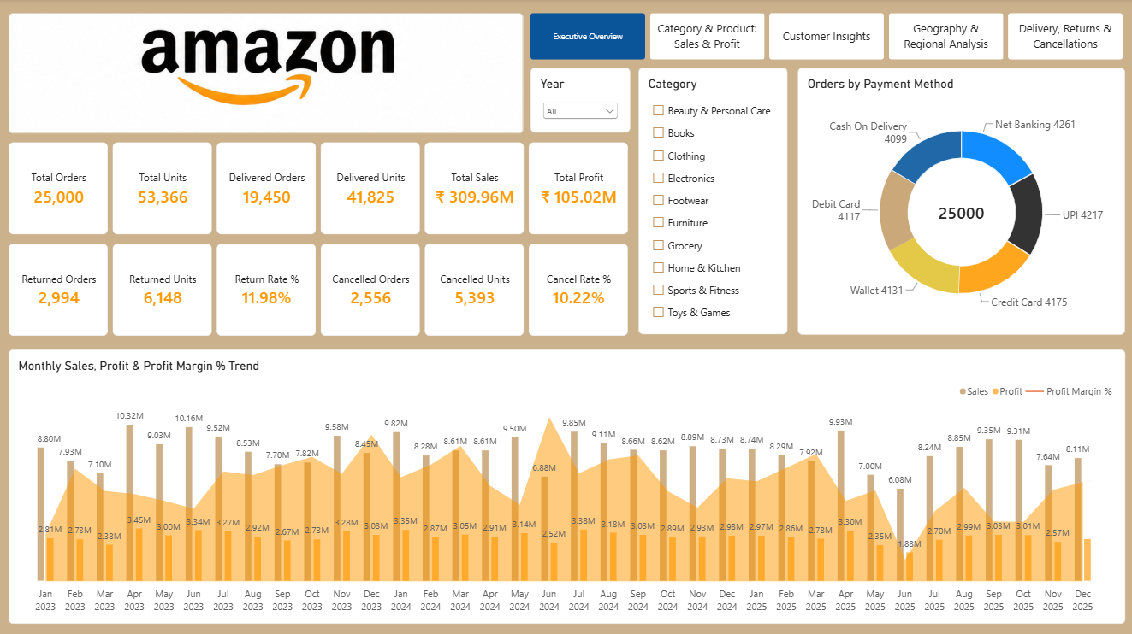

Payment Method Sales Distribution
The Power BI dashboard compares orders, sales across payment methods. The payment-method visual shows how revenue is distributed between the available payment options.
Payment Method | Delivered Orders | Sales | Profit
Cash On Delivery | 3158 | ₹47.85M | ₹16.32M
Net Banking | 4261 | ₹54.76M | ₹18.43M
UPI | 4217 | ₹50.40M | ₹17.22M
Credit Card | 4175 | ₹53.05M | ₹17.45M
Wallet | 4131 | ₹51.96M | ₹17.70M
Debit Card | 4117 | ₹51.95M | ₹17.89M

6.2 Category & Product: Sales & Profit
This page presents:
- Gross Sales
- Total Discount
- Total Sales
- Total Cost
- Total Profit
- Profit Margin %
- Sales and profit by category
- Discount-band analysis
- Top products by sales and profit
- Product, Category, State, and Year filters
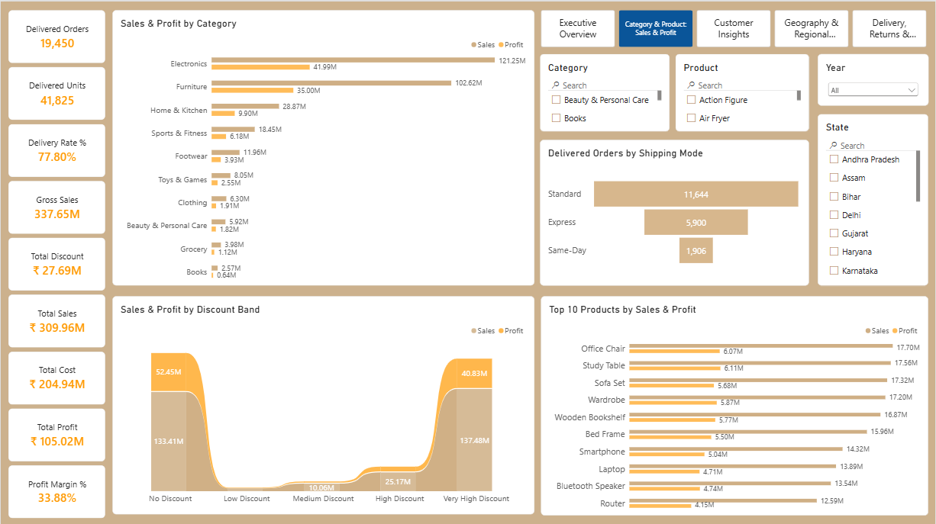
6.3 Customer Insights
This page presents:
- Total Customers
- Never Contributed Customers
- New versus Returning customer analysis
- Purchase Frequency analysis
- Customer value analysis
- Customer ratings
- State-level customer distribution
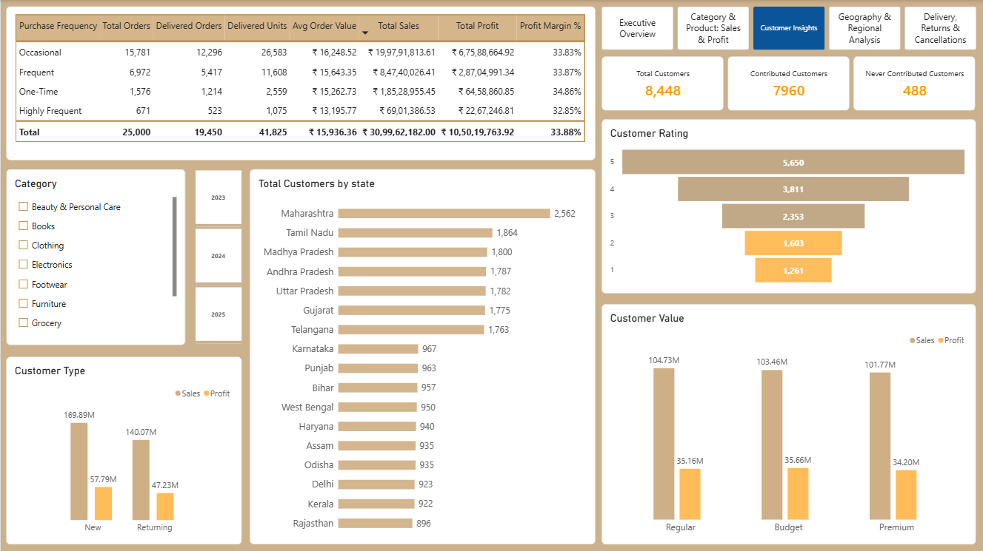
6.4 Geography
This page presents:
- Sales and profit by city
- Geographic map
- State, Category, Region, and Year filters
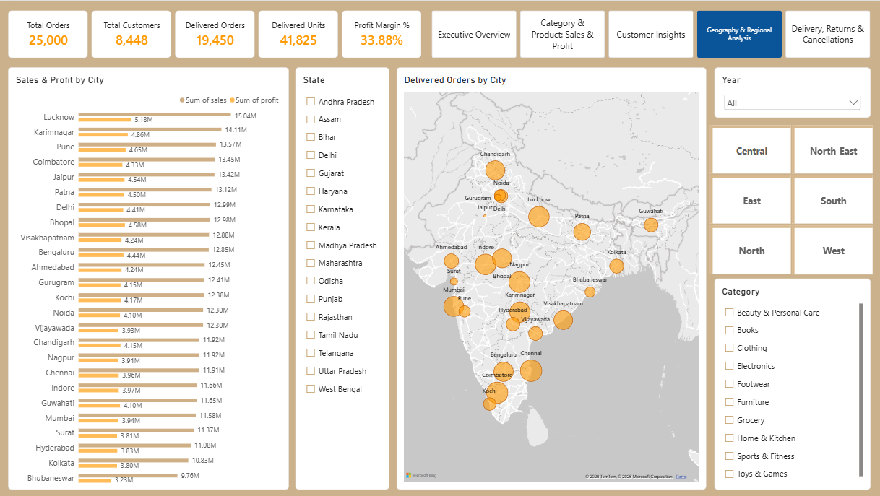
6.5 Delivery, Returns & Cancellations
This page presents:
- Delivery, return, and cancel rate by category
- Return reasons
- Contributed Customers VS Never Contributed Customers
- State-level order-status analysis
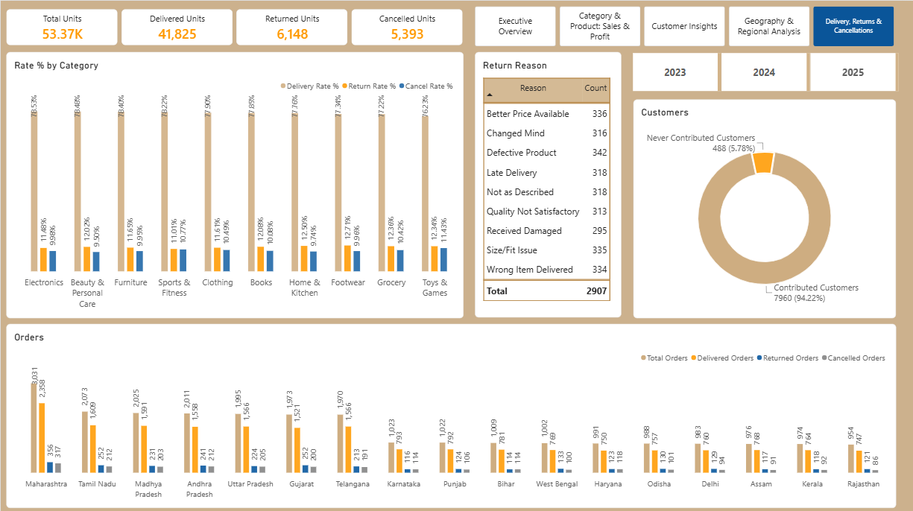

7. Consolidated Business Insights
 | Insight | Evidence
1 | The business is profitable overall. | ₹105.02M profit and 33.88% profit margin
2 | Revenue is concentrated in two categories. | Electronics and Furniture contribute approximately 72% of delivered sales
3 | Electronics is the strongest category. | ₹121.25M sales and ₹41.99M profit
4 | Occasional customers are the largest commercial opportunity. | ₹199.79M sales and ₹67.59M profit
5 | Frequent customers are a valuable repeat-purchase base. | ₹84.74M sales and ₹28.70M profit
6 | Returns require multiple operational solutions. | Return reasons include quality, sizing, fulfillment, price, delivery and product-description issues
7 | Delivery rates vary by category. | 76.23% to 78.53% across categories
8 | Sales fluctuate across months. | Monthly sales range from ₹6.08M to ₹10.32M
9 | Maharashtra is a major market by customer base. | 2,562 customers

8. Patterns and Trends
8.1 Revenue Concentration
The category and product analyses show that delivered sales are concentrated among a limited number of categories and products. Electronics and Furniture together account for approximately 72.23% of delivered sales.
Calculation:
(Electronics Sales + Furniture Sales) ÷ Total Delivered Sales × 100
= (₹121.25M + ₹102.62M) ÷ ₹309.96M × 100
= 72.23%
8.2 Monthly Sales Volatility and Margin Stability
Monthly sales vary considerably, while profit margins remain within a narrower range. Sales volume therefore changes more sharply than overall profitability.
8.3 Customer Acquisition, Frequency and Value
New customers contribute substantial current business volume. Occasional customers generate the largest sales and profit by purchase frequency, while Regular customers generate the highest customer value. These results show that customer acquisition, repeat purchasing and customer value are connected aspects of performance.
8.4 Discount and Profitability
The discount analysis shows that higher sales do not automatically produce higher margins. The Very High Discount band generates substantial sales but a lower margin than the No Discount band.
8.5 Broad-Based Return Causes
Return reasons are distributed across several causes, and return rates are relatively similar across categories. Returns are therefore not limited to one product or category problem.
8.6 Geographic and Operational Variation
The business has a broad geographic customer base, while delivery times, delivery rates and return rates vary modestly across cities and categories.

9. Recommendations
9.1 Protect High-Value Categories and Products
- Maintain product availability in Electronics and Furniture.
- Monitor supplier performance and stock-outs.
- Review profitability for leading products.
9.2 Improve Customer Retention and Value Conversion
- Encourage New customers to make a second purchase.
- Convert Occasional customers into Frequent customers.
- Use personalized product recommendations.
- Retain Regular customers through loyalty benefits.
- Develop targeted offers for Premium customers.
9.3 Reduce Returns Through Targeted Actions
Because return reasons are diverse, return reduction should be addressed by cause.
Return Issue | Recommended Action
Defective Product | Strengthen supplier and quality checks
Wrong Item Delivered | Improve warehouse picking and fulfillment controls
Size/Fit Issue | Improve size charts, product dimensions and customer guidance
Not as Described | Improve product descriptions and images
Received Damaged | Improve packaging and carrier handling
Late Delivery | Improve logistics monitoring and carrier performance
Better Price Available | Review competitor pricing and discount strategy
Changed Mind | Improve product discovery and recommendation relevance

9.4 Improve Discount Management
- Evaluate discounts using sales, profit and margin.
- Set minimum margin thresholds.
- Review heavily discounted products with weak profitability.
- Compare discount performance by product and customer group.
9.5 Investigate Weak Monthly Performance
- Review months with unusually low sales or profit.
- Compare product mix, category contribution and discount levels.
- Monitor monthly performance against established targets.
9.6 Improve Delivery Performance
- Monitor delivery days by city and shipping mode.
- Review locations with higher average delivery times.
- Compare delivery performance with cancellations and returns.

10. Conclusion
This project demonstrates an end-to-end data-analyst workflow using SQL, Excel and Power BI.
SQL was used to profile, clean, validate and analyze the dataset. Excel was used to build an MIS reporting layer and reconcile key measures. Power BI was used to create an interactive dashboard covering executive performance, sales, customers, geography, delivery, returns, and cancels.
The completed analysis confirms that the business is profitable, but it also highlights revenue concentration, significant return and cancellation levels, customer-conversion opportunities and operational improvement areas. The recommendations focus on protecting high-value categories, improving repeat purchases, reducing returns, monitoring discount profitability and strengthening delivery performance.

